**DAILY ONLINE ACTIVITIES SUMMARY**

|  |  |  |  |  |  |  |  |
| --- | --- | --- | --- | --- | --- | --- | --- |
| **Date:** | **29-06-2020** | | | | **Name:** | **B.A.SOHANKUMAR** | |
| **Sem & Sec** | **4TH SEM A** | | | | **USN:** | **4AL18CS013** | |
| **Online Test Summary** | | | | | | | |
| **Subject** | | **----** | | | | | |
| **Max. Marks** | | **----** | | **Score** | | **----** | |
| **Certification Course Summary** | | | | | | | |
| **Course** | **COMPUTER VISION ESSENTIALS** | | | | | | |
| **Certificate Provider** | | | **GLA** | **Duration** | | | **5 HOURS** |
| **Coding Challenges** | | | | | | | |
| **Problem Statement:** **Given a list of numbers, write a Python program to count Even and Odd numbers in a List.** | | | | | | | |
| **Status: EXECUTED** | | | | | | | |
| **Uploaded the report in Github** | | | | **YES** | | | |
| **If yes Repository name** | | | | **LOCKDOWN CODING** | | | |
| **Uploaded the report in slack** | | | | **YES** | | | |

**CERTIFICATION COURSE DETAILS:**

Course: Computer vision essentials.

Today I have opted this new course and this course has a video content of 5 Hours.Completed modules today are Working with Images - Introduction,Working with Images - Digitization, Sampling, and Quantization,Working with images - Filtering,Hands-on Python Demo - Working with images,Hands-on Python Demo: Working with Images.,Introduction to Convolutions,2D convolutions for Images,Convolution - Forward,Convolution - Backward,Transposed Convolution and Fully Connected Layer as a Convolution,Pooling : Max Pooling and Other pooling options,Hands-on Keras Demo: MNIST CNN Building Blocks code walk-through,Hands-on Keras Demo: MNIST_CNN_Cloud,Hands-on Keras Demo: MNIST_CNN_Colab.

 

**CODING CHALLENGES DETAILS:**

1.Given a list of numbers, write a Python program to count Even and Odd numbers in a List. Example: Input: list1 = [2, 7, 5, 64, 14] Output: Even = 3, odd = 2 Input: list2 = [12, 14, 95, 3] Output: Even = 2, odd = 2 Example 1: count Even and Odd numbers from given list using for loop Iterate each element in the list using for loop and check if num % 2 == 0, the condition to check even numbers. If the condition satisfies, then increase even count else increase odd count.

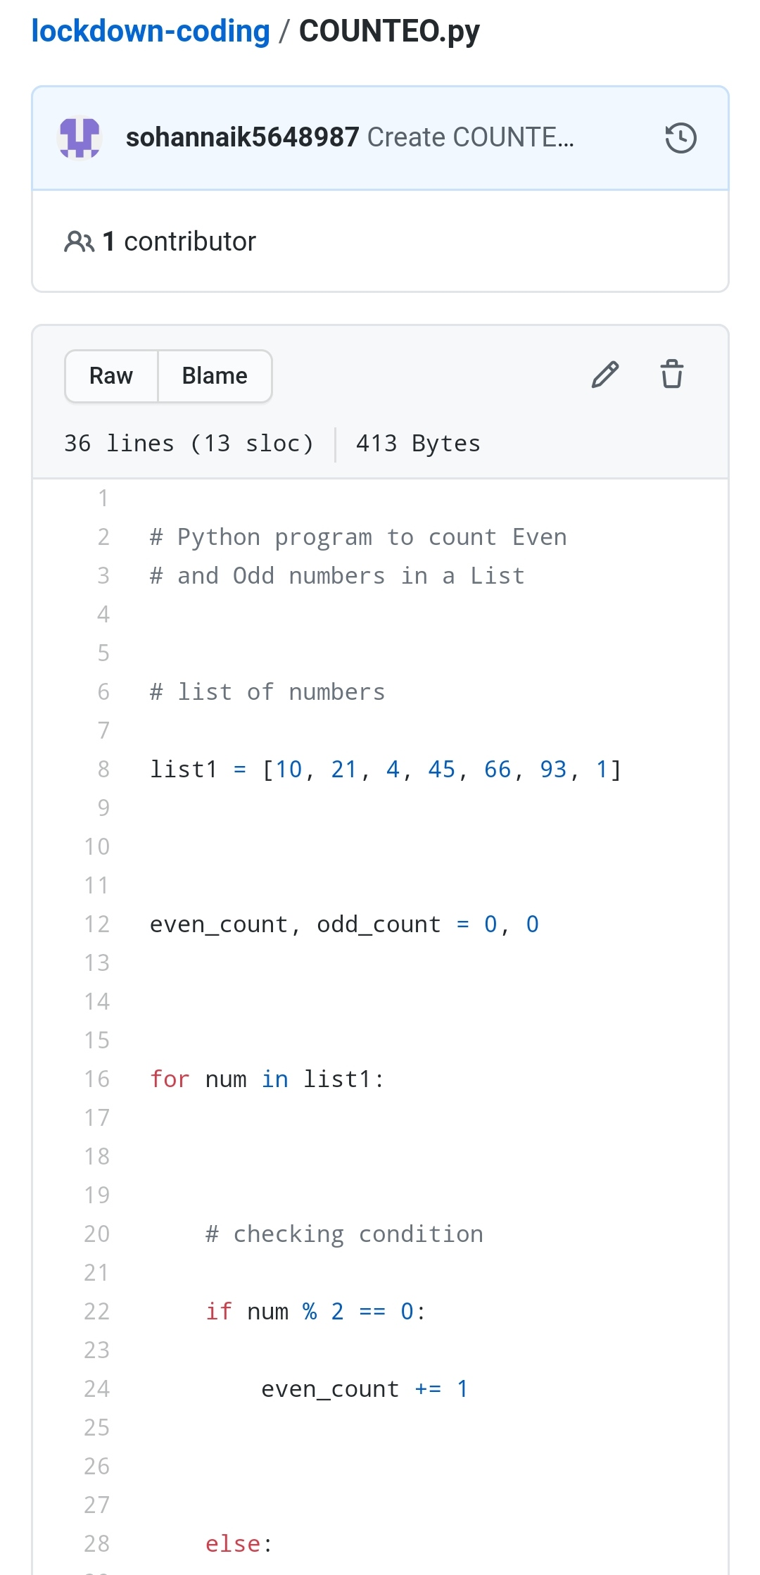

REPOSITORY LINK:https://github.com/sohannaik5648987/lockdown-coding